We will install windows 10 in the pc’s of the office because it is easier for the user to use it and for the information transference and exchange they will use the lan connection. If the user asks for it we can install a software for the information transference.

We also plan to make a partition for the operative system and other for the general use of the user. We want to keep the things simple for the user so it doesn’t get confused.We will also install the full pack of office software and the most common browsers too.

For the server we will use Windows server 2022 because it is the last version and the most used. The server will have a shared folder to store common software or other useful programs or documents that will be needed in the office.

The hardware will be the same as the one in the presentation.

This is the server: [Dell PowerEdge T40 Intel Xeon E-2224G/8 GB/1TB](https://www.pccomponentes.com/dell-poweredge-t40-intel-xeon-e-2224g-8-gb-1tb?campaigntype=pmax&campaignchannel=shoppingcampaignname=pmaxtopsem1&gclid=Cj0KCQjwqP2pBhDMARIsAJQ0Czq_NWnp3JpFJC1XXAzYbeQR_JKAWw18nlIKZ0BW-PhyIex7DPPVVdMaAvYTEALw_wcB)

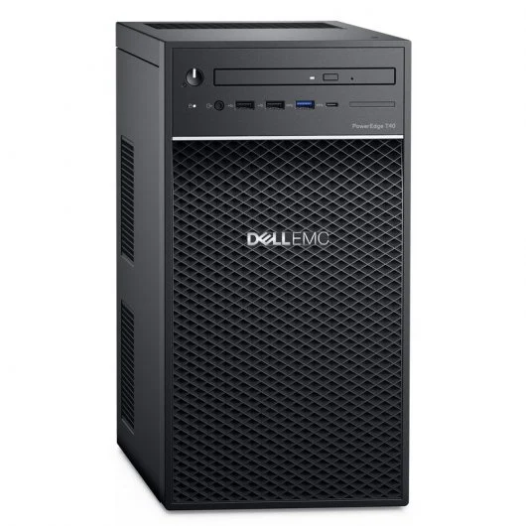

Usernames will be MEBZ.job and the password MEBZdiygarage2023

(IP range for web server 192.168.4.204 and for the users 192.168.4.228-233)